Vendors are now able to upload offers and submit additional documents for open RFPs/IFBs/Other RFQs.
Unless prohibited by the solicitation, DIBBS electronic upload is the preferred method of proposal submission. You may use this screen to upload a completed offer and all associated documents. The offer must be signed and completed in its entirety in accordance with the solicitation requirements. Do not select submit until all associated documents are added. No data will be saved unless the offer is submitted. Once submitted, documents may be added, but not removed.

CAUTION - LATE Submissions, Modifications, and Withdrawals: See Section L, Provision 52.212-1, 52.214-7 or 52.215-1. All offers are subject to all terms and conditions contained in the solicitation.

Reference FAR 15.212-1 (f)(1), which states "Offerors are responsible for submitting offers, and any modifications, revisions, or withdrawals, so as to reach the Government office designated in the solicitation by the time specified in the solicitation. If no time is specified in the solicitation, the time for receipt is 4:30 p.m., local time, for the designated Government office on the date that offers or revisions are due."

NOTE: if the ability to upload proposals is unavailable for any reason, this does not constitute an acceptable reason for a late bid. Please refer to your solicitation for other acceptable submission methods.

Once logged in, you will be able to submit an offer in response to a solicitation found on the RFP search screen by selecting the “Offer” icon. The button will only be selectable for vendors who are logged onto DIBBS. If not logged in yet, DIBBS will take you to the log in screen.

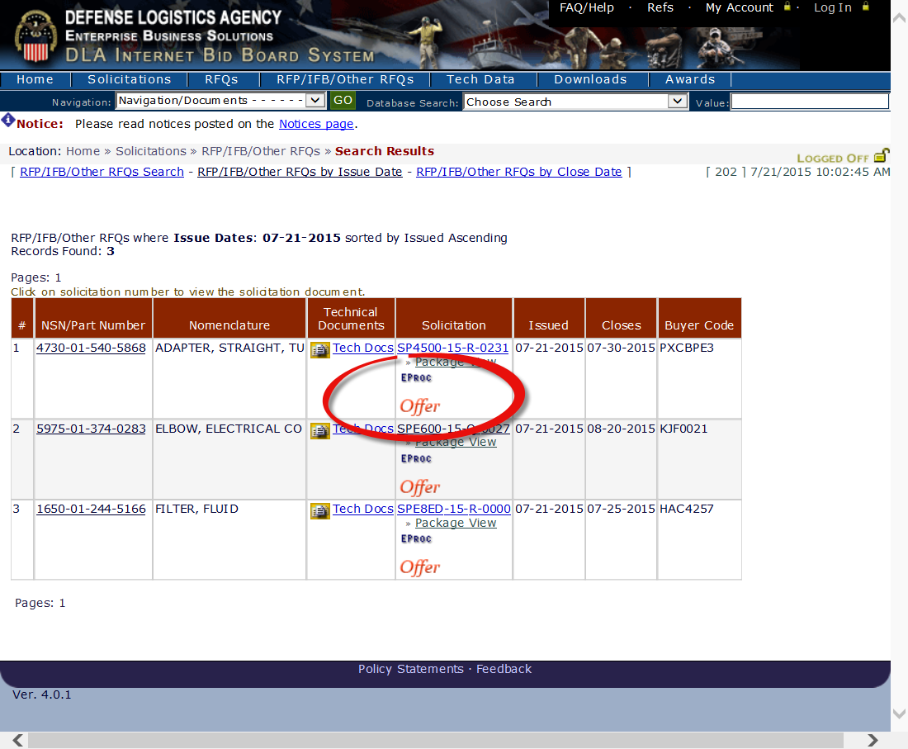

Selecting the Offer icon above will take you to the Upload Offers window

The Upload Offers window contains the following sections:
- Upload Document for Submission – This section allows the vendor to upload documents.
- Uploaded Documents Pending Submission – This section contains documents that have been uploaded, but not yet submitted as part of the offer.
- Submitted Offer – This section contains all files that have been submitted as a part of the offer.

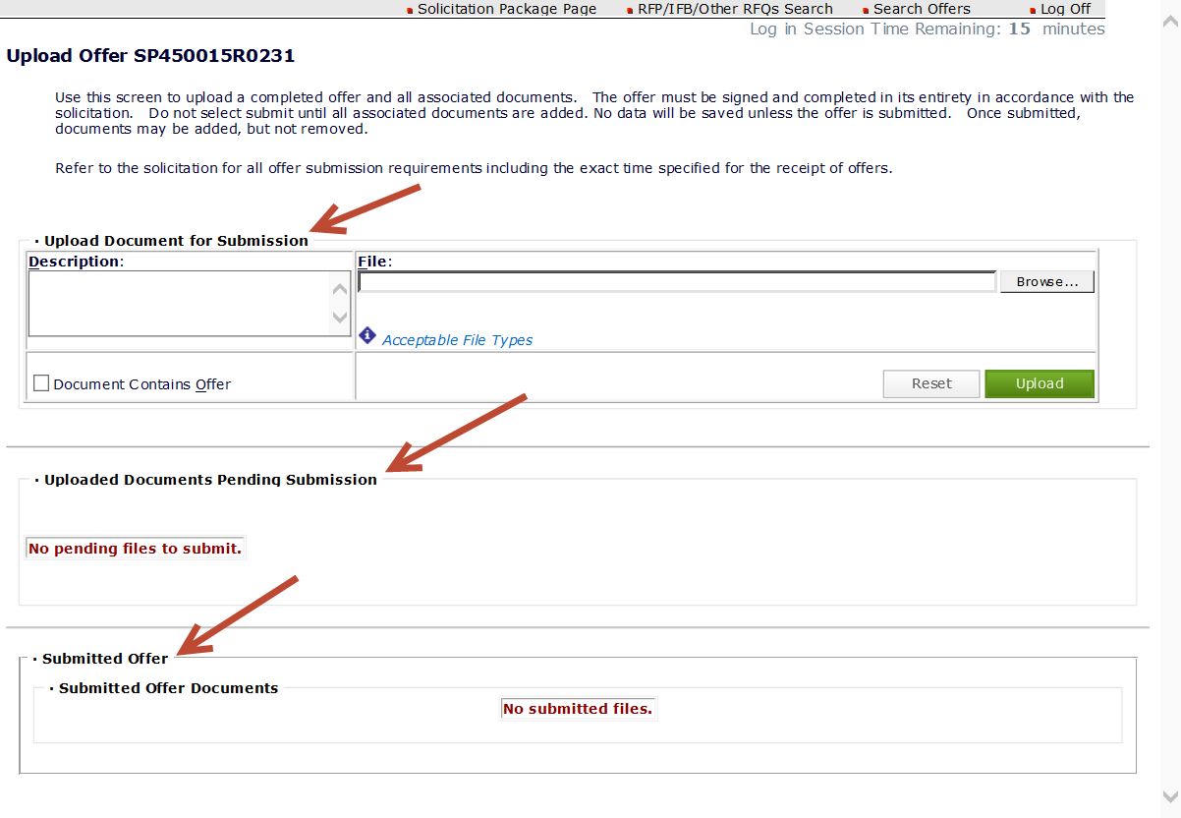
Use this screen to upload a completed offer and all associated documents. The offer must be signed and completed in its entirety in accordance with the solicitation. Do not select submit until all associated documents are added. No data will be saved unless the offer is submitted. Once submitted, documents may be added, but not removed.
Refer to the solicitation for all offer submission requirements including the exact time specified for the receipt of offers.
Description: You can use up to 60 characters to describe each file uploaded. Characters include alphas, numerics, blanks and special characters. Only one file may be uploaded at a time. The Description is a mandatory field.
Note: Uploaded files are not saved until the Submit button is selected.
File Name: DIBBS will allow vendor file names up to 60 positions not including the extension. If the file name is too long, DIBBS will display an error message that the file name is too long.
NOTE: As of 6 Mar 2020, when utilizing the proposal upload function on DIBBS, whatever you name the file will be converted into a standard naming convention when loaded into DLA’s Procurement System. The name of the file you assigned will not change on the DIBBS screen, but only on the screen that our buyers work from. The buyer will see the files you upload as follows: Solicitation number_cage_YYYYMMDD_timestamp_001.file extension. The counter will allow from 001 to 999. When supplying a description of the file, make it descriptive enough so if in any discussion with the buyer on any given file, they can find it quickly. The description you enter will not be changed. They may also ask what date and time you made the upload. It will be important that everyone is looking at the same file. This change was necessary in our continued cybersecurity efforts
Acceptable file extensions for file name: “.doc", ".docx", ".jpg", “jpeg”, “.tif”, “tiff”, “.gif”, ".pdf", ".rtf", ".txt", ".xls", or".xlsx", If not one of these file extensions, DIBBS will display an error message that the file type is not allowed.
If the file size is over 10 MB for a single file, DIBBS will display an error message that files must be less than 10 MB.
**File names cannot contain spaces
The vendor-supplied file name cannot be used more than once for the same offer. If you submit a file name in a previous session, you will not be allowed to use the same name in the current session.
The only acceptable special characters are: hyphen (-) and underscore (_).
Document Contains Offer
This checkbox allows you to select a document that contains your offer.
Reset Button
The Reset button will return all fields in the Upload Document for Submission area to a blank.

Upload Button

The Upload button will move the document from the Upload Document for Submission area to the Uploaded Documents Pending Submission area. If you navigate away from DIBBS without clicking the Submit button, uploaded documents will not be saved. All of the documents that the vendor intends to submit should be uploaded before selecting the Submit button.

Uploaded Documents Pending Submission
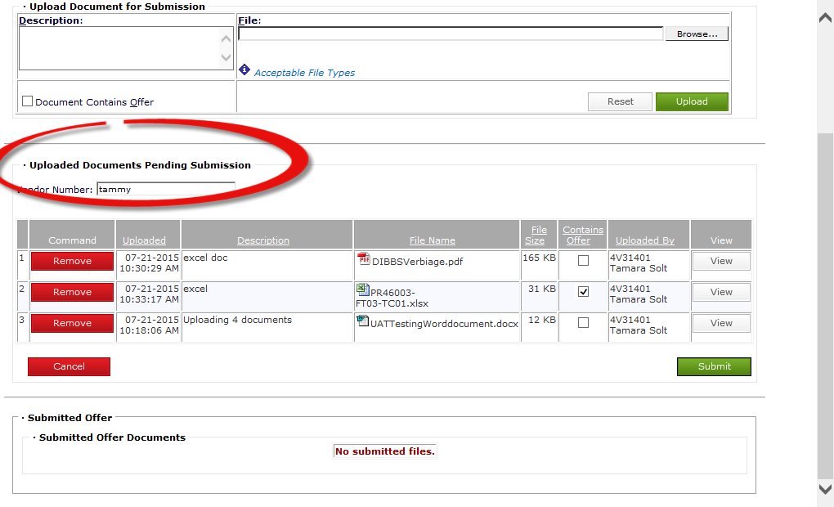
Button Definitions
Remove – The Command column contains a Remove button for each file.
NOTE: Only files that have not been submitted can be selected for removal.
Date – This is the system supplied date/time that the attachment was uploaded.
Description – This field contains the description with up to 60 positions which was entered in the Upload Section.
File Name – This field contains the vendor-supplied name of the file including its extension.
File Size – This field contains the system-supplied file size in bytes.
Contains Offer – This field contains a checkbox which indicates which document contains the offer. Each offer must contain one file that is checked as being the offer.
Uploaded By – This field contains the DIBBS user number and the name of the person who is uploading the files.
View – This column contains a View button for each file that was uploaded.
Vendor Number – This optional field will contain a vendor’s self-supplied offer number. The field may be up to 15 positons long. Acceptable characters are alpha-numeric and hyphens.
Submit – Selecting Submit submits the offer. During the submit process, you will be prompted to select one file that contains the offer. DIBBS will display a printable page confirming that the offer has been received.
When an offer is submitted more than once, selecting a new file as the offer is optional. There is no option to delete any submitted document, but you can submit a revised document. The file name cannot be exactly the same.
Remove – When the Remove button is selected, files checked for removal will be removed and the screen will be refreshed. Only documents that haven’t been submitted may be removed.
Cancel – When Cancel is selected, DIBBS will not save any uploaded files and will return the user back to the previous DIBBS page.
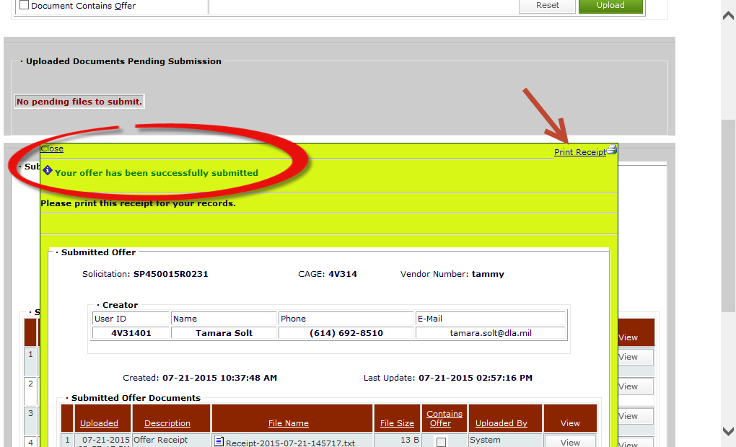
Details for Submitted Offer Documents Section:
Once the Submit button has been selected, the submitted documents are displayed under the Submitted Offer Documents section of the Upload Offer window. All submitted documents are read only.

Prior to the close date of a solicitation, you may submit additional documents
Accessing the Offer after logging off and back on:
You will see a new link called Offers/Search offers under Hot Links from the Welcome page when you first log in.

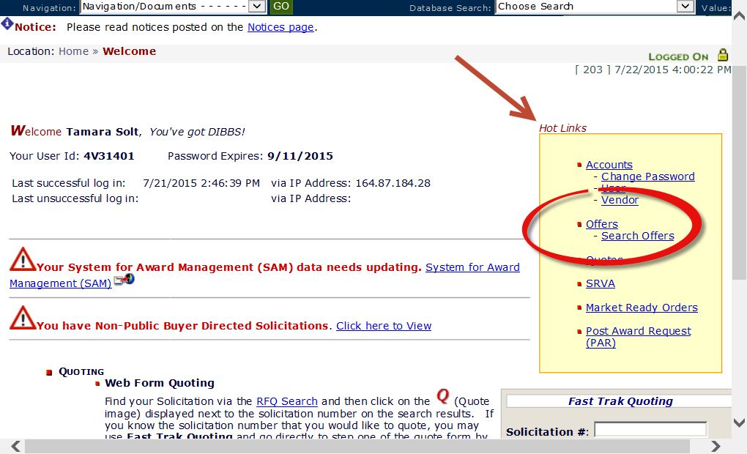
Click on Search Offers where you will be taken to a screen that allows you to search your previously submitted offers. Once found, you can update if desired by clicking on the Update Offer hyperlink.
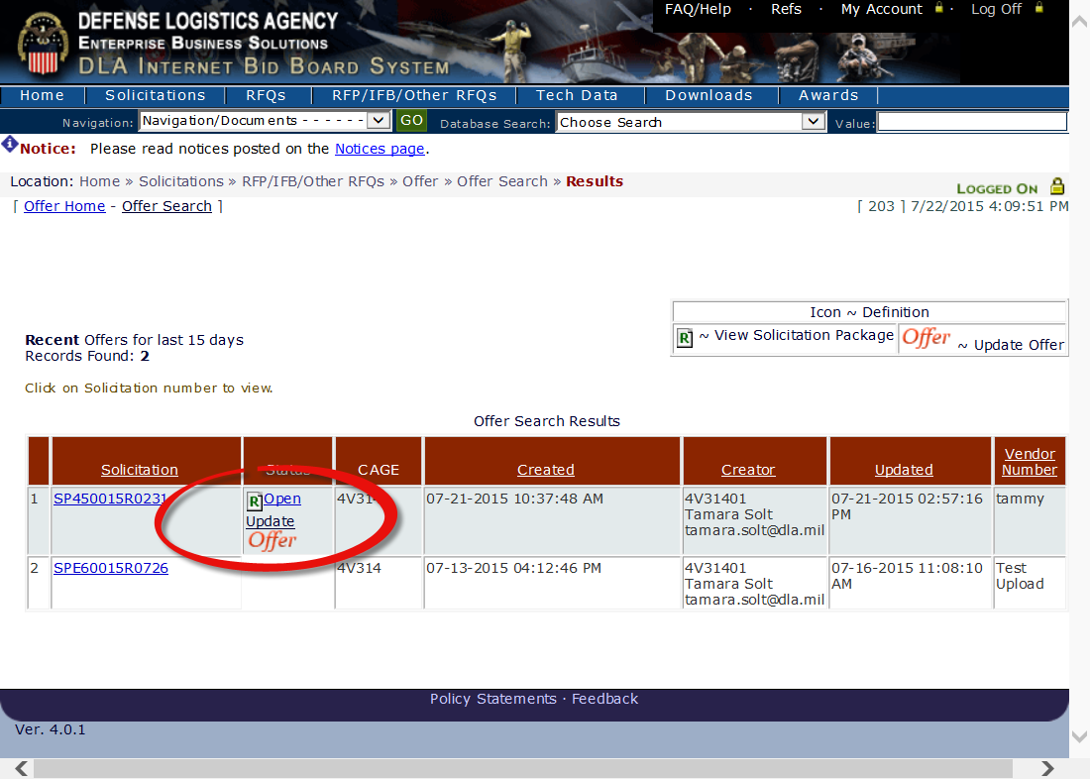
You will be able to view offer until the offer is awarded or until 180 days after the solicitation closes.
If you are logged in and you search for an RFP that you have previously submitted an offer on, you will see a green check next to the word “Offer”
